User Process

1. User inputs address, city, state, and zip code
2. User specifies the range they want to look at (in miles)
3. Application returns analysis with visualization about specific competitors and also about the state in general. ($ means low price, $$ medium, $$$ high price)

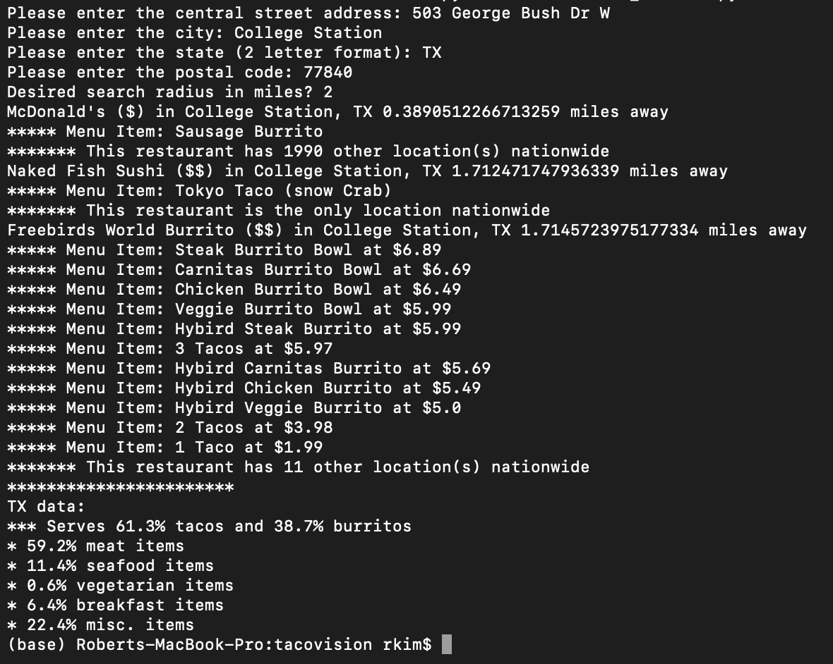

Ideally, the web application would visualize the data into graphs such as this:

**McDonalds**

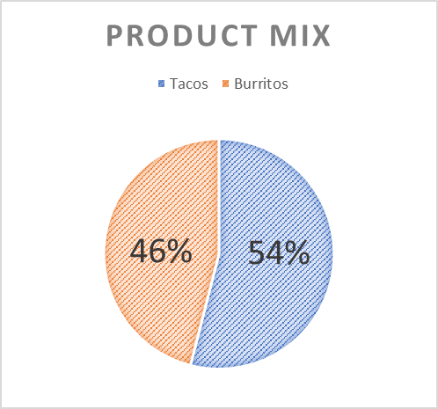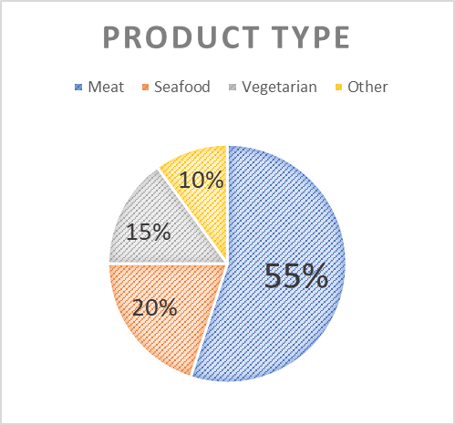

* McDonalds is a “low” price range restaurant
* McDonalds is categorized as “Fast food”
* There are 1990 other locations that sell tacos or burritos nationwide

**Naked Fish Sushi**

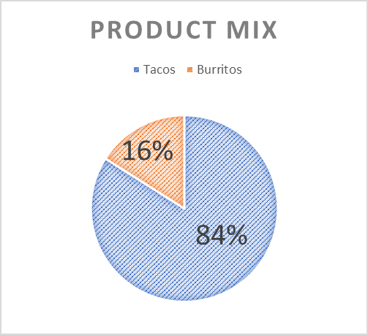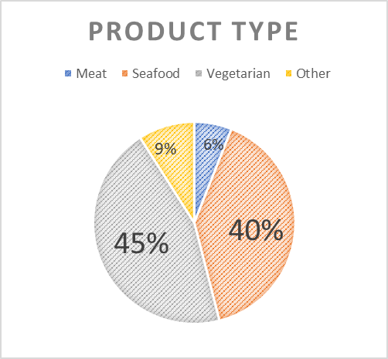

* Naked Fish Sushi is a “med” price range restaurant
* Naked Fish Sushi is categorized as “Japanese”
* This location is the only location nationwide